Electrical Automation Technology, Control Systems Technology & Electrical Systems Design Technology
Performance Test #5, Four-Way Switching

Name _________________________ Instructor Verification __________ Grade __________

Material:
Materials Provided by You | Materials Provided by the Department
1. Necessary Tools | 1. Two Three-Way Switches
2. 14/2 w/Ground NM-B or MC Cable | 2. One Four-Way Switch
3. 14/3 w/Ground NM-B or MC Cable | 3. Lamp Holder
4. Wire Kit | 4. Receptacle

Objective:
Given necessary materials, the student will construct an electrical circuit in 70 minutes, as evidenced by scoring a minimum of 75% on this test.

Time Limit:
You are allowed 70 minutes to complete the circuit. Ten points for every five minutes over the allotted time will be deducted from the score. The maximum overtime allowed is fifteen minutes.

Description of the Circuit:
Construct a circuit in which a lamp holder is controlled from three locations. The duplex receptacle is “hot” all the time. Power is fed to switch box #1. The switch leg is fed out of switch box #3. Power to the duplex receptacle is fed out of switch box #1. All devices and lamp are installed in metal boxes.

Part 1 (+20 points)
Using a straight edge, draw how this circuit will be wired.
Start Time__________ Finish Time__________

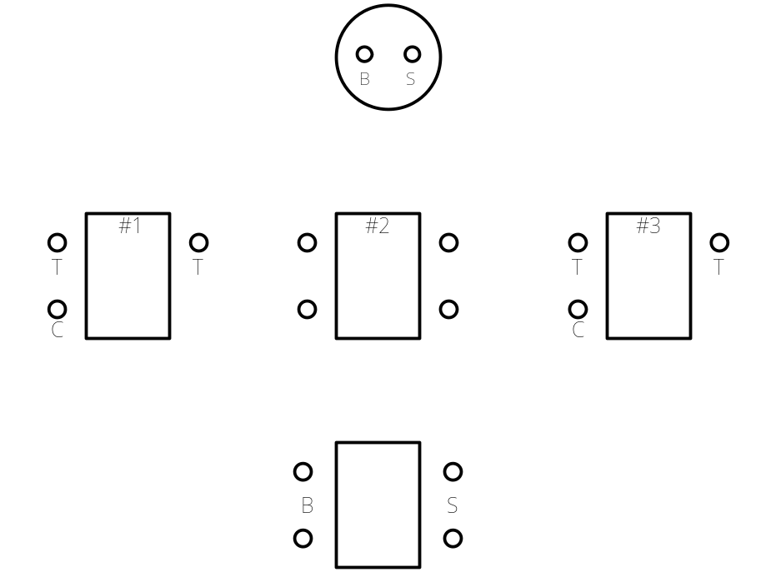
Performance Test # 5

Part #2 (80 points):

Construct the circuit.

__________ Circuit wired to the NEC and fitting tight. +10 points

__________ 6” of free conductor from the edge of the box. +5 points

__________ Wire nut connections secure. +10 points

________ Conductors on devices correctly. +10 points

__________ 1/4” of cable sheath inside box. +5 points (if NM-B is used)

__________ All anti-short bushings in place. +5 points (if MC is used)

__________ Circuit works as described. +40 points (troubleshooting yourself +10 points)

